Date: October 6, 2021

**OATH OF CONFIRMATION**

This is to confirm that I, Craige Jonard N. Baring, a BSIT-3 student, currently enrolled in the course of Capstone Project and Research 2, have aptly received a copy; religiously read and understood its contents; and openly submit to the terms, rules, conditions and regulations stated in the Capstone Project Manual document implemented by the Subject Teacher.

This is also to affirm that said guidelines were judiciously discussed and explicitly elaborated in a forum conducted by the Subject Teacher.

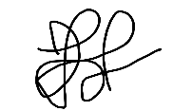CONFORME:

Criage Jonard N. Baring

(Signature of Student over Printed name) / Date

Date: October 6, 2021

**OATH OF CONFIRMATION**

This is to confirm that I, Craige Jonard N. Baring, a BSIT-3 student, currently enrolled in the course of Capstone Project and Research 2, have aptly received a copy; religiously read and understood its contents; and openly submit to the terms, rules, conditions and regulations stated in the Capstone Project Manual document implemented by the Subject Teacher.

This is also to affirm that said guidelines were judiciously discussed and explicitly elaborated in a forum conducted by the Subject Teacher.

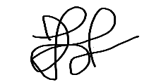CONFORME:

Criage Jonard N. Baring

(Signature of Student over Printed name)/ Date

Date: October 6, 2021

**OATH OF CONFIRMATION**

This is to confirm that I, Rosvie R. Pepito, a BSIT-3 student, currently enrolled in the course of Capstone Project and Research 2, have aptly received a copy; religiously read and understood its contents; and openly submit to the terms, rules, conditions and regulations stated in the Capstone Project Manual document implemented by the Subject Teacher.

This is also to affirm that said guidelines were judiciously discussed and explicitly elaborated in a forum conducted by the Subject Teacher.

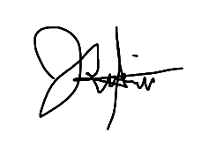

CONFORME:

Rosvie R. Pepito

(Signature of Student over Printed name) / Date

Date: October 6, 2021

**OATH OF CONFIRMATION**

This is to confirm that I, Rosvie R. Pepito, a BSIT-3 student, currently enrolled in the course of Capstone Project and Research 2, have aptly received a copy; religiously read and understood its contents; and openly submit to the terms, rules, conditions and regulations stated in the Capstone Project Manual document implemented by the Subject Teacher.

This is also to affirm that said guidelines were judiciously discussed and explicitly elaborated in a forum conducted by the Subject Teacher.

CONFORME:

Rosvie R. Pepito

(Signature of Student over Printed name) / Date

Date: October 6, 2021

**OATH OF CONFIRMATION**

This is to confirm that I, Sajid Cadavero, a BSIT-3 student, currently enrolled in the course of Capstone Project and Research 2, have aptly received a copy; religiously read and understood its contents; and openly submit to the terms, rules, conditions and regulations stated in the Capstone Project Manual document implemented by the Subject Teacher.

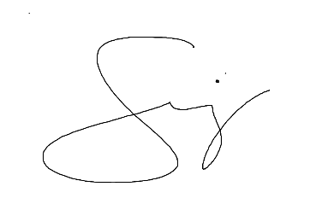This is also to affirm that said guidelines were judiciously discussed and explicitly elaborated in a forum conducted by the Subject Teacher.

CONFORME:

Sajid Cadavero

(Signature of Student over Printed name) / Date

Date: October 6, 2021

**OATH OF CONFIRMATION**

This is to confirm that I, Sajid Cadavero, a BSIT-3 student, currently enrolled in the course of Capstone Project and Research 2, have aptly received a copy; religiously read and understood its contents; and openly submit to the terms, rules, conditions and regulations stated in the Capstone Project Manual document implemented by the Subject Teacher.

This is also to affirm that said guidelines were judiciously discussed and explicitly elaborated in a forum conducted by the Subject Teacher.

CONFORME:

Sajid Cadavero

(Signature of Student over Printed name) / Date